Frontend Development with React.js Project Documentation for Cryptoverse

- Introduction
  - Project Title : Cryptoverse : A cryptocurrency Dashboard
  - Team Members:
Sailesh H(Team Leader) [Email Id: saileshdjsailesh@gmail.com ]
Venkatesan K [Email Id: mohansvenkat44@gmail.com ]
Vignesh K [Email Id: vk6999791@gmail.com ]
Yasin Sherif B [Email Id: yasinsherif491@gmail.com ]

Project Overview
  - Purpose:
Cryptoverse is a feature-rich cryptocurrency dashboard that enables users to analyze historical price data over the past five years. It serves as a powerful tool for investors, helping them make data-driven decisions through interactive charts, comparison tools, and market insights.

- Features:
    - Historical Price Data Analysis: Provides five years of historical data for multiple cryptocurrencies.
    - Interactive Charts: Users can visualize price trends with interactive line charts powered by Chart.js...
    - Educational Resource: Helps users understand market trends and price movements.
    - Crypto Performance Comparison: Enables users to compare various assets for informed investment decisions.
    - Responsive & User-Friendly UI: Built with React.js and styled for an intuitive user experience.

Architecture
  - Component Structure:
The application is built using React.js with a component-based architecture. Major components include:

    - Navbar → Navigation
    - Cryptocurrencies → List of coins

CryptoDetails → Coin info & chart

State Management:
- Redux Toolkit: Manages global state and API data efficiently using createApi for fetching and caching cryptocurrency data.

Store & Middleware: The Redux store integrates API slices and middleware, ensuring optimized state updates and smooth UI performance.

Routing:
The application uses React Router for navigation. Routes include:
    - React Router: Manages navigation between pages like Home, Cryptocurrencies, and CryptoDetails.
    - Dynamic Routes: Enables viewing specific cryptocurrency details using URL parameters (e.g., /crypto/:coinId).

Setup Instructions
  - Prerequisites:
    - Node.js (v16 or higher)
    - npm (v8 or higher)
    - Git

Installation:
- Clone the repository git clone <repository-url>cd crypto verse-app-react
- Navigate to the client directory:
- Install dependencies: npm install
- Configure environment variables: Create a .env file in the client directory and add the necessary variables (e.g., API keys).
- Start the development server: npm start

Folder Structure
- /src → Main source directory containing all application files.
- /components → Reusable UI components (e.g., Navbar, Cryptocurrencies, ryptoDetails, LineChart).
- /pages → Contains primary page components like Home.jsx.
- /services → Handles API calls (cryptoApi.js).
- /redux → Manages state (store.js).
- /app → Core application files (App.js, index.js).
- /assets (optional) → Stores images, icons, and styles.

Running the Application Frontend:
- To start the frontend server, run the following command in the client directory: npm start
- npm install
- npm start
- The application will be available at http://localhost:3000

Component Documentation
  - Key Components:
- Navbar → Provides site-wide navigation links for easy movement between pages.
- Cryptocurrencies → Displays a list of available cryptocurrencies with a search feature.
- CryptoDetails → Shows detailed information, stats, and historical data of a selected cryptocurrency.
- LineChart → Renders an interactive graph of historical price trends using Chart.js.
- Homepage → Displays global crypto market stats and the top-performing cryptocurrencies.
- Loader → Shows a loading animation while fetching data from the API.
- News → Displays the latest cryptocurrency-related news from external sources.

State Management
- Redux Toolkit: Manages global state efficiently using configureStore().
- API Slice (cryptoApi.js): Handles API calls using createApi().
- Reducers: Updates state based on API responses.
- Middleware: Enhances API handling and caching for optimized performance.

User Interface
  - Screenshots
    - Home Page: Display featured tracks and crypto verse.

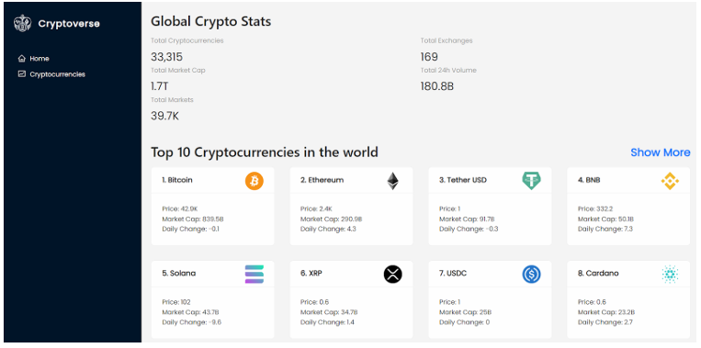

    - Search Page: Allows users to search for crypto currencies and history etc.

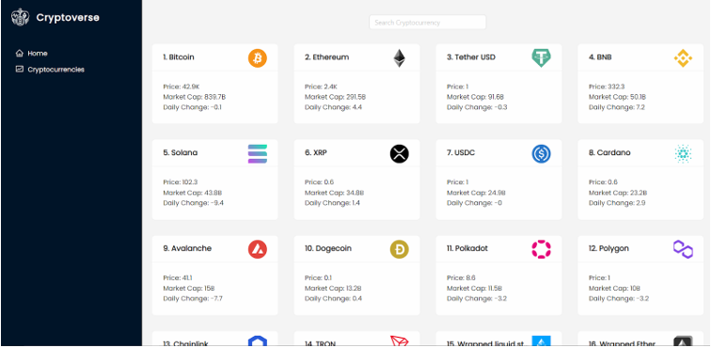

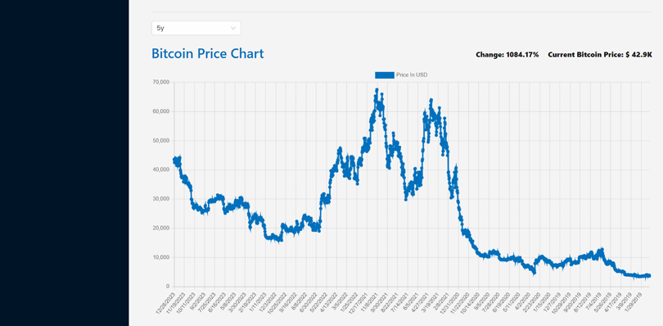

Styling
  - CSS Frameworks/Libraries:
The application uses Styled-Components for styling. This allows for modular and scoped CSS within components.

Theming:
A custom theme is implemented using Styled-Components, with support for light and dark modes.

Testing
  - Testing Strategy:
    - Unit Testing: Using Jest and React Testing Library.
    - Integration Testing: Is performed to ensure that components work together as expected.
    - End-to-End Testing: Cypress is used for end-to-end testing of user flows.

Code Coverage:
    - Code coverage is monitored using Jest’s built in coverage tool. The current coverage is 85%.

Screenshots or Demo
  - Demo Link: https://drive.google.com/file/d/1uKvFUoe95Se6p-uBL-_JEk-KyVb_n2-6/view?usp=drivesdk
  - Screenshots: See section 9 for UI screenshots.

Known Issues

- API Rate Limiting: Excessive requests may hit API limits, causing delays or failures in fetching data.
- Performance Optimization: Large data sets in charts may lead to slow rendering on lower-end devices.

Future Enhancements
  - Future Features:
- Real-Time Price Updates → Implement WebSocket support for live cryptocurrency price tracking.
- Portfolio Management → Allow users to track and manage their cryptocurrency investments.
- Advanced Analytics → Introduce AI-powered insights for trend predictions and risk assessment.
- Mobile App Version → Develop a mobile-friendly version for better accessibility on smartphones.

This documentation provides a comprehensive overview of the crypto verse project, including its architecture, setup instructions, and future plans.

